Amazing Autism!

Resources for children and families that talk about autism and neurodiversity in a neuro-affirming way.

Social Media & Online:

NeuroWild (Facebook, Instagram) Autistic and ADHD speech pathologist, illustrator, advocate, and Mum to 3 ND kiddos.

The OT Butterfly (Instagram, Podcast, Website) Understanding sensory needs, and identifying strategies to support children.

PDA Our Way (Facebook, Instagram) PDA Our Way is a Personal Blog themed around my life as a part of a Neurodivergent family of seven.

NeuroClastic (Facebook, Instagram) NeuroClastic, Inc., is an Autistic and ADHD-led 501(c)3 disability rights non-profit.

Pandas online (Facebook, Instagram, Website) Promoting acceptance of neuro divergency and support.

I CAN Network (Facebook, Instagram, Website) Australia's largest Autistic-led organisation.

Spectrum Gaming (Facebook, Instagram, Website) Charitable organisation helping parents and young people understand autism and connect through gaming.

Barriers to Education – Autism and Trauma (Website) A neurodiversity-affirming guide for parents and professionals (by Spectrum Gaming)

Mind Your Autistic Brain (website)

Books:

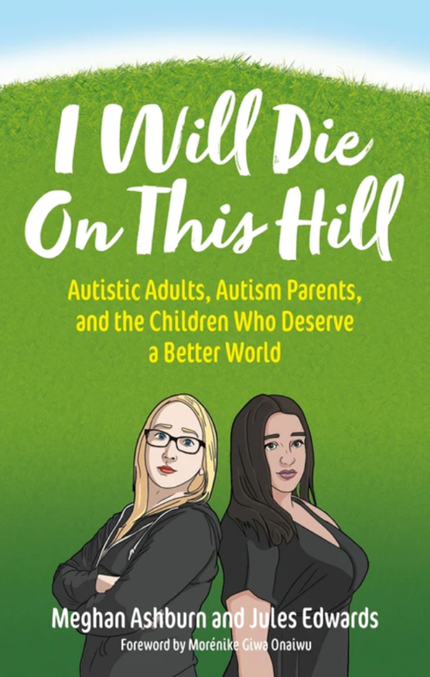
There is a significant divide between autistic advocates and parents of autistic children. Parents may feel attacked for their lack of understanding, and autistic adults who offer insight and guidance are also met with hostility and rejection. Meghan Ashburn, a mother of two autistic boys, and Jules Edwards, an autistic parent, were no strangers to this tension and had an adversarial relationship when they first met. Over time, the two resolved their differences and are now co-conspirators in the pursuit of disability justice.
This book unites both perspectives, exploring the rift between these communities and encouraging them to work towards a common goal. It provides context to dividing issues, and the authors use their experience to illustrate where they've messed up, where they've got things right, and what they've learned along the way.
- Published: Jan 19 2023
- Pages: 256
- 214 x 136mm
- ISBN: 9781839971686

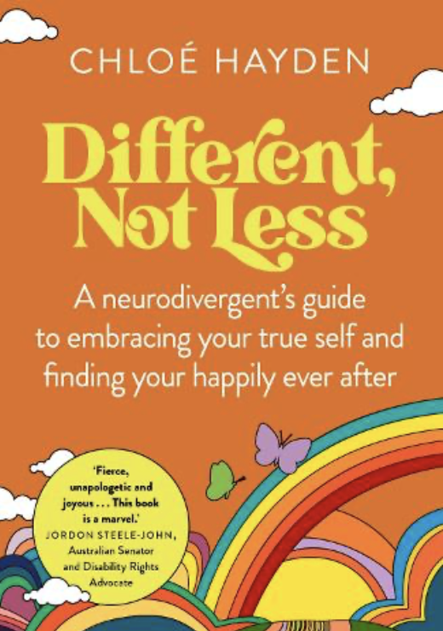
Growing up, Chloe Hayden felt like she'd crash-landed on an alien planet where nothing made sense. Eye contact? Small talk? And why are you people so touch-oriented? She moved between 10 schools in 8 years, struggling to become a person she believed society would accept, and was eventually diagnosed with autism and ADHD. When a life-changing group of allies showed her that different did not mean less, she learned to celebrate her true voice and find her happily ever after.
This is a moving, at times funny story of how it feels to be neurodivergent as well as a practical guide, with advice for living with meltdowns and shutdowns, tips for finding supportive communities and much more.
Whether you're neurodivergent or supporting those who are, Different, Not Less will inspire you to create a more inclusive world where everyone feels like they belong.
Publisher: Murdoch Books
ISBN: 9781922616180
Number of pages: 288

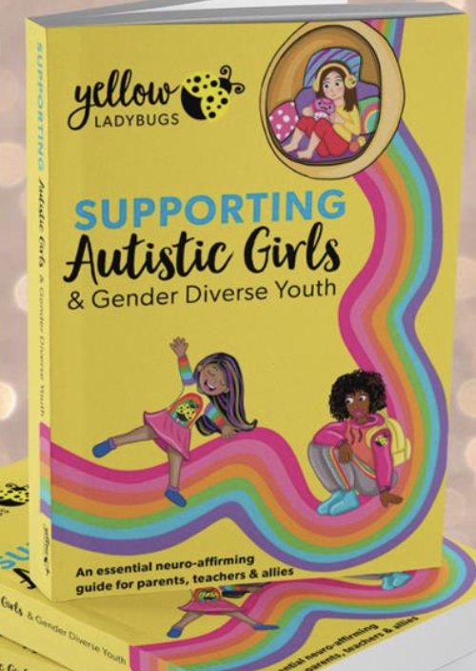
Want to know how to better support autistic girls and gender diverse youth? This is an authentic resource for parents, teachers and allied health professionals written and illustrated by autistic women and gender diverse individuals. You will be given the inside scoop, through their intimate knowledge, recollections and advice from growing up autistic.

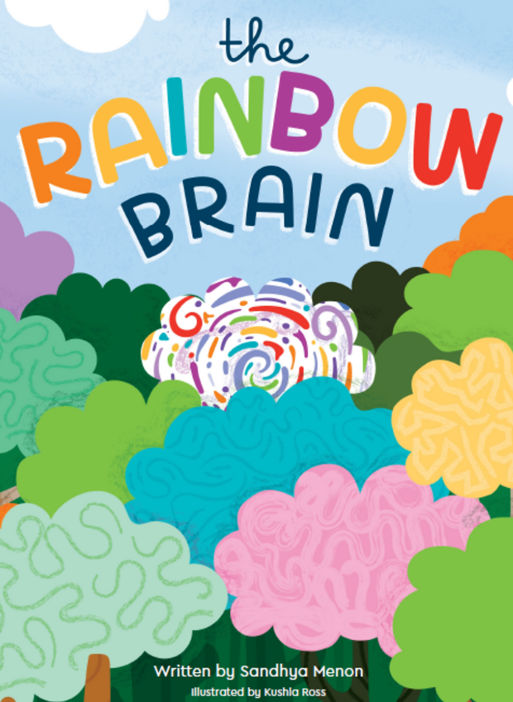
The Rainbow Brain is an inspiring and colourful children's book that is the first of its kind to describe what it's like to be both autistic and ADHD. It is a neuro-affirming introduction to identity, designed to encourage children to explore and celebrate their uniqueness whilst understanding their accommodations.
Filled with delightful illustrations and a vibrant colour palette, this book is sure to make a lasting impression on young readers, making it an invaluable resource for any family and educator.

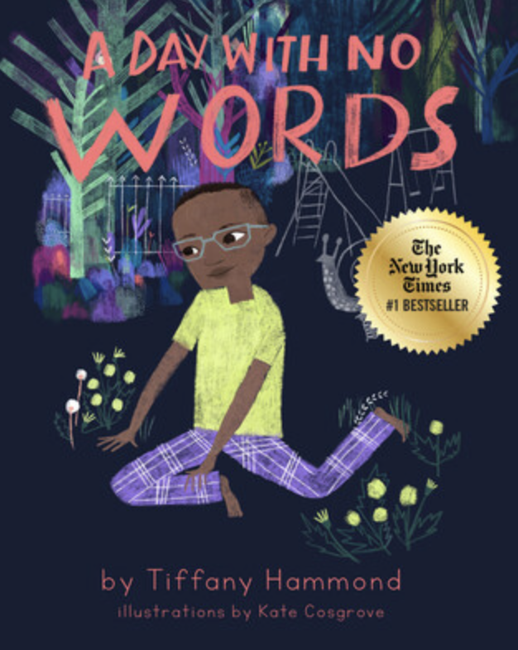
An instant #1 New York Times bestselling picture book and national bestseller!! A Day With No Words invites readers into the life of an Autism Family who communicates just as the child does, without spoken language.
The American Library Association Booklist starred review boasts, “The story is written from the boy's first-person perspective, however—a clever choice in that it gives readers a direct look into his mind and reinforces the book's crucial statement that nonverbal people have as many words and as much intelligence as anyone else. Cosgrove's art, throughout, does an amazing job of transporting readers into his perspective, employing various color tones, metaphoric imagery, and ‘camera’ angles to reflect the deep expressiveness contained in every page [...] through this book, neurotypicals' eyes will be opened, and everyone in Autistic Families will feel seen—and heard.”
A Day With No Words is a colorful and engaging picture book for young readers shares what life can look like for families who use nonverbal communication, utilizing tools to embrace their unique method of "speaking."
The story highlights the bond between mother and child and follows them on a day where they use a tablet to communicate with others.
Written by an autistic mother of two autistic sons and the creator behind the popular @Fidgets.and.Fries social media platform and illustrated by Kate Cosgrove (IG @k8cosgrove), A Day With No Words successfully normalizes communication methods outside of verbal speech and provides representation of neurodiversity and autism in a way that affirms and celebrates.

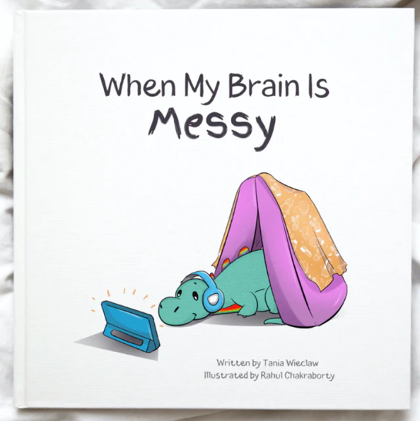
When My Brain Is Messy is an engaging children's picture book that beautifully captures the world of Sensory Processing Differences. Connect with different sensory experiences, discover effective tools, and embark on a journey of co-regulation for children and their parents during sensory-sensitive moments.

Join the lovable young dinosaur on a journey through sensory experiences, where they rely on their parents' help to navigate overwhelming moments and big emotions. It's a story filled with understanding, compassion, and finding inner calm through regulating activities. Written by an autistic author and mother, Tania Wieclaw.

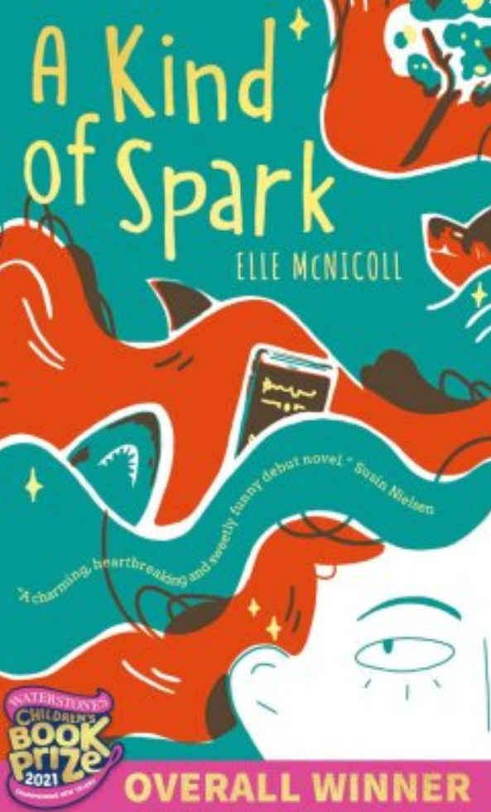
A Kind of Spark tells the story of 11-year-old Addie as she campaigns for a memorial in memory of the witch trials that took place in her Scottish hometown. Addie knows there's more to the story of these 'witches', just like there is more to hers.
Can Addie challenge how the people in her town see her, and make her voice heard? A story about friendship, courage and self-belief, perfect for fans of The Goldfish Boy, Addie’s story was born from Elle’s own experiences of neurodiversity and her commitment to seeing greater representation in children’s books.
Publisher: Knights Of Media
ISBN: 9781913311223

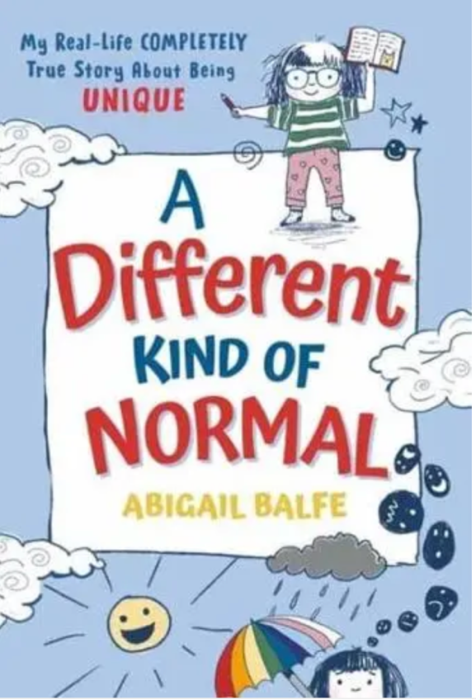
Hi! My name is Abigail, and I'm autistic. But I didn't know I was autistic until I was (kind of) an adult. This is my true story of growing up in the confusing "normal" world, all the while missing some Very Important Information about myself. There'll be scary moments involving toilets and crowded trains, heartwarming tales of cats and pianos, and funny memories including my dad and a mysterious tub of ice cream. Along the way, you'll also find some Very Crucial Information about autism. Important, funny, and completely unique, this book is for anyone who has ever felt different.

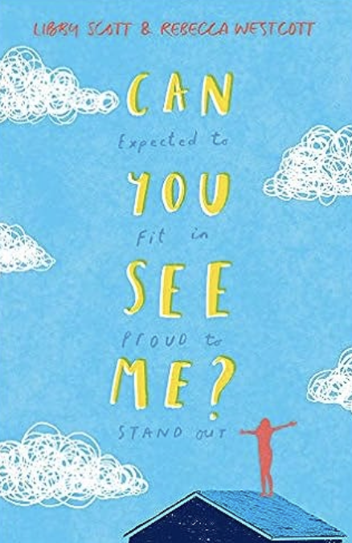
With diary entries written by eleven-year-old Libby Scott, based on her own experiences of autism, this pioneering book, written in collaboration with esteemed author Rebecca Westcott, has been widely praised for its realistic portrayal of autism.
Tally is eleven years old and she's just like her friends. Well, sometimes she is. If she tries really hard to be. Because there's something that makes Tally not the same as her friends. Something she can't cover up, no matter how hard she tries: Tally is autistic.
Tally's autism means there are things that bother her even though she wishes they didn't. It means that some people misunderstand, her and feel frustrated by her.
People think that because Tally's autistic, she doesn't realise what they're thinking, but Tally sees and hears - and notices - all of it.
And, honestly? That's not the easiest thing to live with.
- The first book written in collaboration with Libby Scott
- When Libby's mum shared a short piece of Libby's writing online it soon went viral, with tens of thousands of people saying that Libby's writing helped them understand autism for the first time
- This fictionalised portrayal of a young autistic girl is written by Rebecca Westcott, in close collaboration with Libby Scott, making it a truly original and inspirational book that will give readers of all ages a deeper understanding of what it's like to be autistic
- Perfect for fans of The Goldfish Boy, Wonder and The Curious Incident of the Dog In the Night-time

