Transgender people and suicide fact sheet

Transgender (trans) people face unique stressors, including the stress some trans people experience when their gender identity is not affirmed. Trans people also experience higher rates of discrimination and harassment than their cisgender counterparts and, as a result, experience poorer mental health outcomes. They are also at a greater risk for suicide as they are twice as likely to think about and attempt suicide than LGB people (Haas et al., 2011; McNeill et al., 2017; Irwin et al., 2014).
GENDER IDENTITY refers to a personal conception of one’s place on the gender spectrum; the gender that one identifies as may be the same or different from their birth assigned sex.
TRANSGENDER (trans) is an umbrella term that represents a wide range of gender identities and expressions. Trans people do not identify either fully or partially with the gender associated with their assigned sex at birth (Canadian Federation of Students, 2017).
WHY ARE TRANS PEOPLE AT RISK?
There are a few factors that put transgender people at risk of suicide, factors that can put strain on one’s mental health and potentially lead to thoughts of suicide:
- Institutional prejudice manifesting as laws and policies which create inequalities and/or fail to provide protection from discrimination
- Experience of discrimination (transphobia) in the form of physical or verbal harassment, physical or sexual assault
- Lack of support from parents and other family members
- Stress related to fear of transitioning, including the potential backlash and life disruption, as well as considering the risks and sometimes lengthy time period involved
- Gender dysphoria, or distress related to a conflict between one’s physical or assigned gender and the gender with which they identify (Bailey et al., 2014; Haas et al., 2011; Suicide Prevention Resource Center [SPRC], 2008; Taylor et al., 2011).
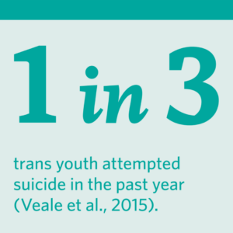1 in 3 trans youth attempted suicide in the past year (Veale et al., 2015).

What can reduce risk?
- Supportive and strong relationships with family and friends
- Completed medical transition (if medical transition is desired)
- Self-awareness and acceptance
- Access to gender affirming health care
- Not having access to lethal means such as guns or potentially deadly medications
- Having one’s name and pronouns accepted (Bailey et al., 2014; Bauer et al., 2015a; Haas et al., 2011; SPRC, 2008).
WARNING SIGNS
Any significant change in behaviour or mood is a warning sign that someone may be thinking about suicide, for example:
- Losing interest in a previously enjoyed hobby or activity
- Disconnecting from friends or family (not calling as much, not going out)
- Change in sleeping or eating patterns
- Increased and excessive drug and/or alcohol use

