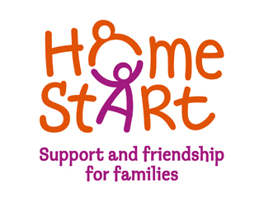

Name, Job title  
Company name  
Date  
someone@example.com

Annual Report 2017/18



**Home-Start Wyre Forest**

Registered Charity No: 1120436 A Company Limited by Guarantee No 5419029

# Chairman`s Report

Welcome once again to the Annual Report for Home-Start Wyre Forest. This report covers the period October 2017 to September 2018. It has been another busy year with new challenges and opportunities for everyone involved.

The need for Home-Start help and support appears to be greater than ever. This service, which provides non-judgmental support and befriending to families in The Wyre Forest through regular home visiting from our volunteers and Family Groups now works not only with families with under 5s but also families with older children. During the last year we supported 367 children in 185 families. Our wonderful volunteers continue to give excellent help and support to families who have a widening variety of needs.

Our Family Groups continue to flourish both in Kidderminster and Stourport thanks to funding support from DY10 HBG Big Local, Tesco Bags for Help, Awards for All and Midcounties Co-operative. These are making a big difference not only to the children who attend but also help to reduce the isolation felt by many parents.

DY10 HBG Big Local is very supportive to Home-Start Wyre Forest in a variety of way as we work together to improve family and community life in the area.

Our first year as the Midcounties Co-operative Charity of the year in the Wyre Forest area has been a wonderful support to us. Not only have we benefited from the extra funding from the stores and bag packing sessions, but our families have been able to enjoy special times together with a trip to Weston in the summer and a great Christmas party organised by Co-op staff. The staff have been welcoming in the stores and some have even volunteered again to participate in the Gung-Ho! sponsored event in the coming months.

Although not officially covered by the Annual Report for 2017/2018 I would like to say how delighted we are to have been awarded The Community Fund Lottery Grant for “Safe and Strong” work with families, continuing our partnership with The Family Psychologist team in the coming five year period.

We would like to give a big thank you to all our sponsors and funders, big and small, for their financial help and support. Also to everyone who attended our fundraising events, your support is very much appreciated.

We were very sorry that it was necessary to make another member of our staff team redundant, in late 2018. We thank her for all her hard work with the family groups and at the scheme and wish her well for the future.

There have also been changes in the management committee. We have lost Phil Hoar and Tracey Wilkes, who are unable to attend because of changes in their life. Anne Taylor, our esteemed Treasurer, also retired after several years of keeping the books balanced. We thank them all for their hard work and commitment. We are very pleased to welcome Brian Price as our new Treasurer.

A big thank you to all the staff, fantastically well lead by Belinda, who continue to work extremely hard in providing appropriate help to the many families in their care and in providing excellent support for all our volunteers.

I would like to thank all at Home-Start Wyre Forest, staff, volunteers, trustees and all who support in any way so that together we can continue to provide an excellent service to our community by meeting the challenges and making the most of any new opportunities that arise.

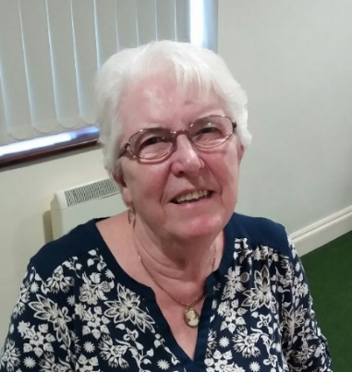

Megan Weaver

Chairman

# Life President`s Report

As I said last year how quickly these AGM’s come around. Looking back, I first became involved with HSWF nearly twenty years ago, when the staff of three had a small unit on the site of the Sugar Beet Factory and where I did my prep course. I have been involved with HSWF ever since.

There have been highs and lows on the way to developing the scheme as it stands today, with a lot of hard work being done by a number of people. Now we have an extended scheme liaising with other organisations such as DY10 HBG Big Local and running After School Groups as well as looking after families and volunteers, delivering prep courses and attending events relevant to the scheme.

Belinda puts tremendous effort into getting adequate funding, a lot of which has to be spent on specific activities. It is very helpful to have unrestricted funds to cover core costs, which are difficult to fund in any other way. We are very grateful for the donations received from individuals, businesses and charities, particularly the Midcounties Co-operative who support us financially and also help by sponsoring events, such as our Annual General Meeting.

Very many thanks to Belinda, Donna, Joanne and Lynda for their continued dedication and hard work. Thank you also to all the volunteers, without whom there would be no Scheme.

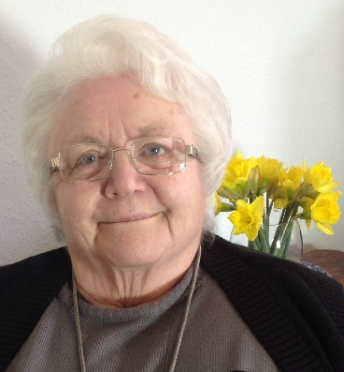

Barbara Hughes

Life President

**Treasurer`s Report**

**Overview**

The financial landscape for Home-Start Wyre Forest in 2017/18 was dominated by the ending of the Lottery funding which in 2016/17 totalled £144,600 and represented 62% of the year’s total income. This funding ended because the Lottery Grant was fixed for 3 years. We subsequently entered a continuation application, but this was unsuccessful. It is hoped that a new long-term grant from the Lottery will be agreed during 2018/19.

Home-Start Wyre-Forest is reliant upon philanthropic and corporate grants and the generosity of individuals as no direct public sector funding is received. However, we do benefit from two major publicly funded grants being DY10 Big Local and Children in Need.

We started the year with substantial funding balances as the Lottery funding received in 2016/17 covered the period up to the end of December 2017. This gave breathing space for other avenues of funding to be pursued and all credit to Belinda Darby, our scheme manager, for her sterling efforts at securing other sources of income.



Brian Price

Treasurer

**Income**

Despite the efforts at sourcing other funds our total income in the year reduced by almost 50% from £231,382 to £119,179.

This income was made up as below:

|  |  |  |
| --- | --- | --- |
| **Funding Source** | **2017 18** | **2016 17** |
|  | **£** | **£** |
| BBC Children in Need | 29,317 | 24,688 |
| Eveson Trust |  | 8,000 |
| Big Lottery |  | 144,592 |
| DY10 HBG Big Local | 39,572 | 25,017 |
| M.K.Rose Charitable Trust | 3,000 | 3,000 |
| Groundwork UK |  | 1,650 |
| St James Place |  | 1,000 |
| St John Middlemore |  | 2,000 |
| KAISF | 1,748 | 2,005 |
| Lloyds Bank Foundation | 7,949 |  |
| Midcounties Co-operative | 6,290 |  |
| Four Acre Trust |  | 2,500 |
| Tesco Bags of Help | 2,000 |  |
| Garfield Weston | 10,000 |  |
| Stourport Mayor's Charity | 2,881 |  |
| Lasletts Hinton Trust | 2,000 |  |
| Albert Hunt | 3,000 |  |
| Bank Interest | 52 | 55 |
| Other Income and Donations | 6,270 | 9,259 |
| Fundraising | 5,100 | 7,616 |
| **Total** | **119,179** | **231,382** |

The Charity Partnership that we signed with Midcounties Co-operative in January 2017 has proved to be very beneficial and the help and support from them that we receive is still growing and is invaluable, not only bag packing but also in a number of other ways.

Even though we have not received direct funding from the Lottery this year our partnership with DY10 Horsefair, Broadwaters & Greenhill (HBG) Big Local, which itself is Lottery funded, has proved beneficial in many ways with projects supporting families in these areas. DY10 HBG Big Local was our largest funder providing us with £39,572.

Also much appreciated was a public funded grant from BBC Children in Need at £29,317. Garfield Weston at £10,000 was our other major supporter.

The amounts are not everything and we remain indebted to the many individuals, Corporate and Charitable donors who support us throughout the year. These funds are vital to enable us to try to grow the levels of support that we can offer.

**Expenditure**

In the knowledge that the Lottery funding would cease during the year the Board implemented several initiatives to reduce expenditure. These succeeded in reducing expenditure from £196,131 in 2016/17 to £166,366 in 2017/18. This was a decrease of £29,765 which was a reduction of 15% which partly offset the fall in income. The expenditure was made up as below:

|  |  |  |
| --- | --- | --- |
|  | **2017 18** | **2016 17** |
|  | **£** | **£** |
| Staff Costs | 118,944 | 137,703 |
| Volunteer Expenses | 4,879 | 6,471 |
| Operational Costs | 42,543 | 51,957 |
|  |  |  |
| **Total** | **166,366** | **196,131** |

**Surplus / Deficit**

Collating the Income and Expenditure figures above results in the following Surplus / Deficit position:

|  |  |  |
| --- | --- | --- |
|  | **2017 18** | **2016 17** |
|  | **£** | **£** |
| Income | 119,179 | 231,382 |
| Expenditure | 166,366 | 196,131 |
| **Surplus / -Deficit** | **-47,187** | **35,251** |

The Surplus of £35,251 has become a Deficit of £47,187, a decrease of £82,438.

**Available Funds and Reserves**

In October 2017 we started with a strong cash position of £114,372, of which £28,000 was a formal reserve to cover the costs of closure, should that eventuality occur. The Board meets regularly and reviews the level of this reserve to ensure that all commitments could be met for closure costs and redundancy payments. This reserve is held in an interest-bearing account to provide separation from day-to day funds. All other funds remain available for use in the short to medium term and no long-term or speculative investments are held.

The requirements for this reserve were re-evaluated during the year and the reserve was increased to £35,000. With the deficit in the year and the increase to the reserve the balance of available funds carried forward to 2018/19 was £32,185, a reduction of £54,187 on the prior year

|  |  |  |
| --- | --- | --- |
|  | **2017 18** | **2016 17** |
|  | **£** | **£** |
| Funds Brought Forward | 114,372 | 79,121 |
| Surplus / -Deficit | -47,187 | 35,251 |
| **Funds Carried Forward** | **67,185** | **114,372** |
| Of which |  |  |
| Designated reserve | 35,000 | 28,000 |
| Available funds | 32,185 | 86,372 |
| **Total Funds Carried Forward** | **67,185** | **114,372** |

**The Outlook for 2018 19**

In the short term in 2018/19 we foresee a squeeze on funding as our balances are depleted. However, we remain optimistic and will continue to pursue alternative sources of funding. We are hopeful that an application for Lottery funding will be accepted in 2019. The Board will review costs and discuss ways in which we can reduce our operating overheads to bring them in line with income. We remain ever-grateful to all of our sponsors, our staff, our volunteers and our partners and we remain confident that we will be able to continue to provide the valuable support that we offer to the many families who need that little extra help.

# What is Home-Start ?

Home-Start Wyre Forest (HSWF) is a Family Support Charity, offering practical and emotional support to parents with children in their own homes and at groups, helping to alleviate stress and prevent family breakdown.

We can offer support to families with children (0-18 years), living in the Wyre Forest District and with family consent for referral. Many families we support are experiencing difficulties with mental health, isolation, drugs or alcohol, housing, a multiple birth or may have experienced past traumas, such as domestic abuse.

Our core service is our weekly home-visiting volunteer visits of 2-3 hours a week, offering emotional and practical support and befriending. This may include providing conversation and a safe person to talk to, helping isolated families to make links in the community, or supporting parents in playing with their children and enjoy time together, despite the difficulties they are facing.

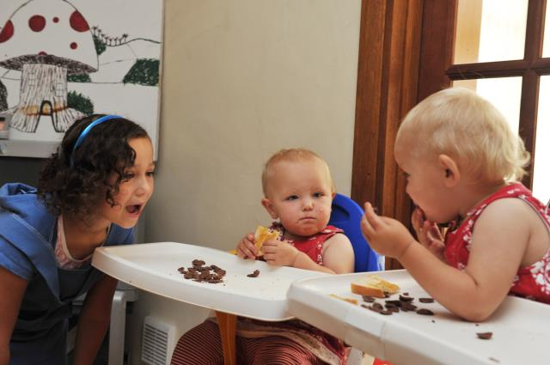

Most of all, the volunteer builds a trusting, friendly relationship with the family they support over a significant period of time. Our average support has now increased from 6-9 to 9-12 months, with families with more complex needs coming to us for support.

**During 2017/18 we received 133 referrals and supported 367 children in 185 families.** 52% of the children we supported were aged under 5 years, 48% between 5 and 18 years of age. 62% of families we supported this year had Social Care contact, with 49% having a Child Protection or Child in Need Plan in place, a process to which we make a significant contribution.

**Our Family Groups**

The main purpose of our Family Groups is to provide somewhere safe and supported for the most vulnerable families in our community to meet, form friendships and gain support. In addition to providing the standard weekly structured sessions and activities we enable families to enjoy their time together, feel part of the wider community and develop and feel proud of new skills.

**We run the following groups 46 weeks of the year (funder in brackets):**

* Tuesday Kidderminster After School Group (DY10 HBG Big Local)
* Wednesday Stourport After School Group (Midcounties Co-op)
* Thursday Pre-school Group (Awards For All, Tesco 2017/18)
* Thursday Kidderminster Afterschool Group (DY10 HBG Big Local)

These sessions are a way of promoting a sense of self worth, belonging and acceptance which many of these parents and children have never experienced.

We can see these connections made through our Family Groups are the foundations for future social confidence and competencies which will be needed by the adults and child in these vulnerable families to manage future adversity and ensure a happy, safe and productive future, wherever their aspirations are focused.

During 2017/18 **84 parents and 99 children** used our groups, providing an essential opportunity for social contact and interaction, emotional support and awareness of community services.

 *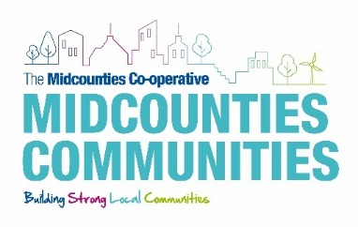 ***



 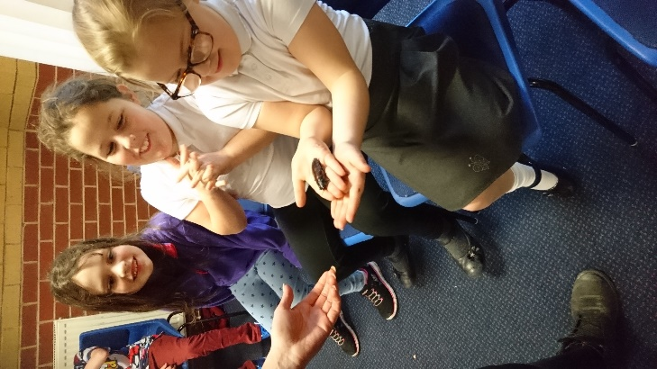

**Animal Lady Visit to After School Group January 2019**

The groups have been accessed in the past year by some of the community`s most isolated families and it is noted the feedback we have had this year records 100% of parents attending (for the second year running!) say they feel they have made friendships through the group.

In 2018 we asked the families who attend what does Group mean to them :

*“Home-Start and the Family Group have given me a new outlook on life. The love, care and support they provide is beyond words. I have never known a more caring charity and I for one am blessed to have these wonderful people in my life.*

*They give families that light at the end of the tunnel when life is in the dark and they are there to make sure the light stays lit and help you find your way.*

*Even on your saddest day these ladies can definitely make you smile again. They really are the meaning of “laughter is the best medicine” and not a day goes by that I am not forever grateful for how warming Home-Start are and their generosity and compassion they give to anyone they meet. They really are earth`s angels. (HSWF Mum, Pre-school Group)*

*“All our friends are here”.(HSWF Dad, Afterschool Groups)*

*“This is the best place to be.” (HSWF child, aged 8, Afterschool Groups).*

Local donations of food, toiletry items and end range goods from Midcounties Co-operative and Tesco are taken to the Groups to be distributed to families, which is a great way of reducing costs for families and providing accessible, healthy goods which families can take home at the end of the session.

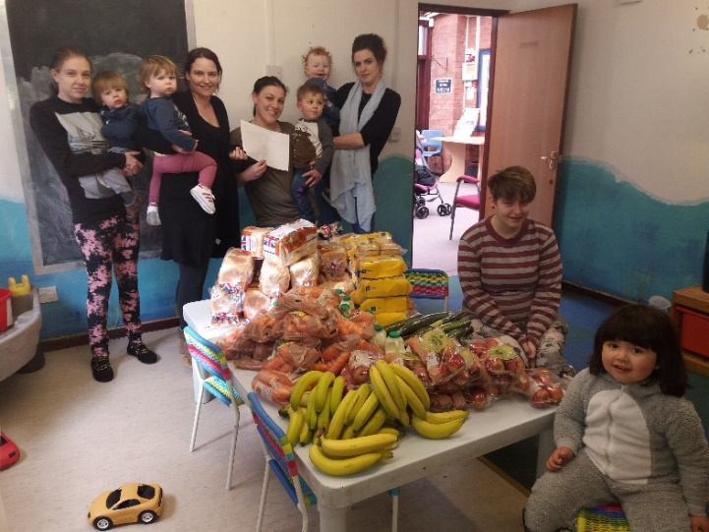

**Families at the pre-school Group enjoy fresh donations from**

**Midcounties Co-operative**

**Measuring Impact**

The support we deliver to families is recorded, monitored and evaluated through our Evaluation Framework, which records data in the following areas:

|  |  |
| --- | --- |
| **Systems and Learning**   * What is enabling access? * What are barriers to support? * What are we learning about delivery? | **Case Studies**   * How is trust being developed? * How are our Volunteers Growing? * How support is paid forward? |
| **Aligned Funding and Benefits**   * Match funding attracted * What have we saved the public purse? * What are the secondary benefits of our approach? | **Data**   * How many people are we supporting? * How many volunteers are we engaging? * What is the financial value of our service? |
| **References and Testimonies**   * Volunteers * Beneficiaries * Referrers * Aligned agencies | **MESH (Monitoring and Evaluation System Home-Start)**   * Baseline evaluation of need * Mid and end evaluation of need * “Distance travelled” measured |

This enables us to record evidence of the impact of our support throughout the year, not only for individual families, but for the wider community and aligned local and national agencies. Our staff carry out needs assessments with families at the beginning, during and at the end of our support, to ensure our involvement is helping the family and to allow us to change the focus of support and to assess impact.

Our unique befriending service over a significant period of time can produce life changing results for both parents and the children we support and particularly contributes to improved outcomes in the areas of parental and child health, emotional health and wellbeing (including past trauma), reduced isolation and managing child behaviour.

**Our Families say….**

My children have complex needs and part of that is they struggle with group

settings, making and keeping friends, separation from me, sharing and saying

goodbyes. Due to their adoption background, these things are very traumatic for my children to deal with and so the repetition of attending Group is building their

resilience to be able to manage, (not necessarily cope with) these situations,

which will provide them with skills they`ll be able to transfer to other situations. With the consistent, regular and similar set up and workings of the groups, my

children now find it easy to attend, despite their anxieties around group settings

and social expectation. (HSWF Mum, 2018).

A massive thank you! Everyone in the office is lovely and our volunteer has made a massive difference in our lives. She would sit and play with {my son} and it is

clear he loves he – his little face lights up whenever he sees her. She was also

amazing listening to me. This really helped as I have lost a lot of friends since

becoming ill and felt very isolated. Honestly, I feel she has become part of the

family and is like a second mum to me. Thank you for sending her to us!

(HSWF Mum, 2018).

Very helpful and I would be lost without their support. They have so much

support for families that need it and they encourage you to join in the activities

that my little girl loves. (HSWF Mum 2018)

Thanks to HSWF and having them in my life since my daughter was so little,

they have helped me fight for my daughter and the help she needs. They have

been a constant support, even though I am not completely out of my shell. Two

years ago I would not have been able to attend groups because I was so painfully

shy. They have helped with that. Me and my child have made some exceptional

friends through the groups. (HSWF Mum 2018)

**

**Our Referrers and partners say….**

I knew they would be looked after once you guys got on board. (Marie Martin, Social Worker, 2018)

Thank you so much for all your support. Both mother and baby have blossomed over the last few months and having their volunteer as a stable and constant support has been invaluable. (Marie Tandy, Community Midwife)

Thanks for all your great work. (Tina McKenzie, Health Visitor)

**Our Volunteers say….**

I really enjoyed playing with the boys. I loved helping Mum become more positive and have confidence in herself. (Sandra, 2018).

I found it very satisfying working with my family. The thing I enjoyed most was seeing how Mum gained confidence and it has been fab watching the children grow. The support from my Co-ordinator was brilliant. (Jayne,2018).

What started off as a simple befriending requirement became much more complex as the months went on. A steep learning curve for me but very enjoyable. I enjoyed how welcoming the family were and the relationship we built up. I loved the way {the child} got to know me and got excited when I arrived. I have always felt extremely well supported from the moment I was accepted as a Volunteer with HSWF, right through and including when I was with my families. (Sue,2018).



**Our Volunteers**

We trained 8 new volunteers this year and a team of 102 community members volunteered their time during the year to deliver our service or govern the scheme.



**End of Preparation 2018**

All home visiting volunteers complete a 40 Hour Course of Preparation, covering many subjects including Safeguarding Children and Vulnerable Adults, Confidentiality, Mental Health and Domestic Abuse. As part of our Safer Recruitment Practices we also carry out home visits, reference checks and obtain a Disclosure and Barring Service (DBS) Enhanced Disclosure for all volunteers. Following the course, we then offer **On-Going Training**, to further develop the volunteers` skills and support their own personal and professional growth. This and which this year included sessions on :

* When a loved One Dies (Midcounties Co-op Funeral Care)
* Safeguarding Children and Young People Refresher

All our training resources are uploaded to our website [www.homestartwyreforest.org.uk](http://www.homestartwyreforest.org.uk) to ensure those volunteers who cannot make the courses can gain basic awareness of the subject and as a place to refresh their knowledge of past training.

**Looking after our Volunteers**

All volunteers receive regular support and supervision from a named

Co-ordinator while linked with a family and this is complemented by group support sessions, when volunteers can share experiences and discuss solutions around the challenges of volunteering in a confidential setting, facilitated by paid staff. Our quarterly newsletters are sent to all volunteers, together with up to date news on our website and facebook page.

We recognise long service at each Annual General Meeting and of our 102 volunteers 34 have long service awards (given at 5, 10 and 15 years), with 5 volunteers having served 15 years or more with us!

**National Volunteer Week**

In June 2018 Midcounties Co-operative, as part of our Charity Partnership hosted our National Volunteer Week Event in their Stourport Store Coffee Shop.

National Volunteer Week is an annual opportunity to officially thank our amazing team of volunteers for the time, energy and commitment they give to the scheme each week, whether by home visiting, help at our Family Groups or by governing the scheme as charity trustees and advisors.

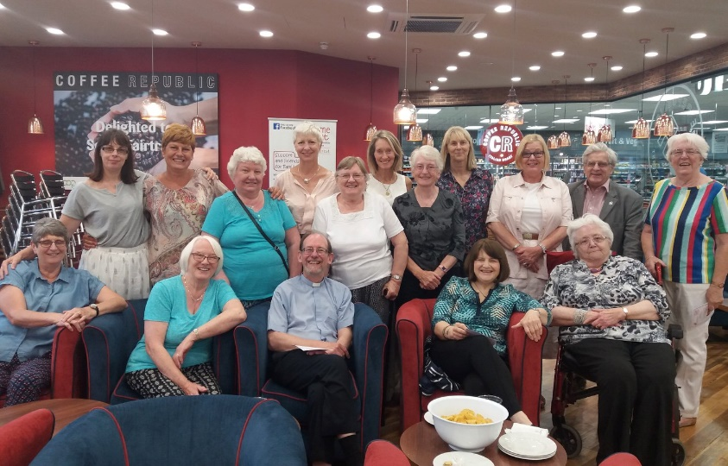 

**Working in Partnership**

In addition to working cooperatively with many local groups this year, we have held three significant, formal partnerships.

**DY10 HBG Big Local **

This is a Lottery funded nighbourhood improvement project working in parts of Horsefair, Broadwaters, and Greenhill in Kidderminster. Unlike other initiatives, this Plan is designed by the community, for the community and delivered by a Partnership led by residents of that community.

In 2017/18 we were able to : access funding to support our volunteering and support opportunities for their residents, provide the partnership with HR support through recruitment, training and line management of their project staff and join them at their activities and events for local families.

**The Family Psychologist **

Our scheme continued to work in partnership with the team at The Family Psychologist to further develop our joint project for community psychology (Safe & Strong) and the wider supporting services under the community benefit model Future Families. Lloyds Bank Foundation funded management hours at our scheme so we could dedicate time to this partnership work during a two year from 2018. This work continues with the aim of setting up an additional service for our families where we can offer a package of Psychological therapy alongside our family support : **Safe & Strong – Psychology and Family Support for adults and children in The Wyre Forest.**



**Midcounties Co-operative **

In January 2018 we began a two year Charity Partnership with the Wyre Forest group of Midcounties Co-operative (MC) businesses. A Regional Community Group meet regularly to plan and review community action, including fundraising and support for their Charity Partner. We were overwhelmed by the enthusiasm of this group to help us, not only in raising funds and our profile, but also in delivering additional activities to our families. This has included :

* Setting up and funding a new After School Family Group in Stourport
* Hosting a Family Fun Day at Franche Store to raise funds and provide community activities
* Enabling HSWF staff and volunteers to bag pack in stores four days each month
* Supporting our Fundraising events
* Collecting donations at outlets across the Wyre Forest on our behalf
* Hosting a party for HSWF Families in May in the Stourport Coffee Shop
* Funding a day at the seaside for our families August 2018



**In the first 9 months of this partnership an amazing £9899 has been raised !**

**Supporting other Community Groups**

We are very proud to have been involved in supporting the setting up of a parent led support group for those whose children have additional needs with past service user Jayne Maclean. **SENsational Parents Wyre Forest** now has over 100 members on line and arranges social and support meetings on a regular basis.

We will continue to support the group in the coming year as they begin fundraising for funds to support social activities for parents with and without their children. Contact Jayne on [jaynemaclean1968@gmail.com](mailto:jaynemaclean1968@gmail.com) for group information.

**Fundraising Events**

During the course of the year we arranged events to raise much needed unrestricted income for the scheme and to raise our community profile.

* In November 2017 a Fashion show at M & Co., arranged by HSWF Director Tracey Wilkes (below left) raised £433 for the scheme.

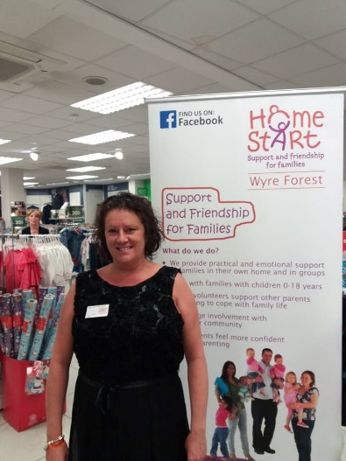 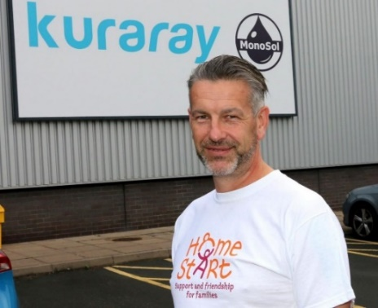 

Gary Burke (above right), an employee of Company Monosol, Hartlebury, who have chosen us as Named Charity to support, ran the Snowdonia Marathon in October 2017, raising £460 for the scheme.

Our largest fundraising event of the year was the **Gung**-**Ho! 5KM Seriously Fun Challenge** (supported by Midcounties Cooperative) in June 2018. A team of 27 runners went Gung-Ho! Crazy at Cofton Park, Birmingham, and raised over £2000 for the scheme.Midcounties Co-op even supplied the Gungho! Gecko!

 

**Christmas Toy Appeal** 

We were delighted to be partners once again in the Kidderminster Shuttle Christmas Toy Appeal, where members of the public bought gifts for the children of families who were receiving support from us and passed them on through the scheme anonymously. An amazing 805 gifts were donated in December 2017 and passed onto families, demonstrating true community spirit and making the festive season a little happier.

**Snowflake Appeal**

This annual appeal runs from November to January and encourages supporters to arrange Snowflake themed events to raise funds for HSWF. This year over £300 was raised.



**The HSWF Team**

|  |  |  |
| --- | --- | --- |
| **The Board** |  |  |
| Megan Weaver | Chairman | Current |
| Barbara Hughes | Life President  Vice Chairman | Current  To May 18 |
| Jill Acton | Vice Chairman | From May 18 |
| Anne Taylor | Treasurer | To May 18 |
| Brian Price | Treasurer | From Sept 18 |
| Roger Bourne | Director | Current |
| Linda Small | Director | Current |
| Rev. Phil Hoar | Director | To July 18 |
| Tracy Wilkes | Director | To Feb 19 |
| **The Staff** |  |  |
| Belinda Darby | Manager | Current |
| Donna Scriven | Senior Co-ordinator | Current |
| Lynda Williams | Scheme Secretary | Current |
| Joanne Shinton | Co-ordinator | Current |
| Sam Littleton | Family Group Worker | To Dec 18 |
| Heidi Preston | Co-ordinator | To Dec 17 |
| Nikki Beeston | Scheme Support Worker | To Dec 17 |

**Thank you to our wonderful volunteers:**

Amanda, Amie, Ann C, Ann F, Anna, Atlanta, Brenda, Catherine, Celia, Charlotte, Christine, Dawn L, Derek, Dorothy, Elaine, Ellie, Emily, Esther, Everleen, Gary, Harj, Hayley, Heather, Helen B, Helen H, Jackie, Jane, Jayne, Jenny, Joanna, Jodie, Joy L, Joy P, Julia , Julie B, Julie P, Julie S, Katie, Kayleigh, Karen G, Karen W, Kelly, Kim L, Kizzy, Lakami, Lara, Laura, Lesley B, Lesley D, Lisa, Liz I, Liz H, Liz S, Louise G, Louise S, Louise T, Lucie M, Lucie P, Lynne, Margaret, Marjorie M, Marjorie W, Marissa, Marnie, Maz, Megan, Myra, Nancy, Nicky A, Nicky P, Norma, Paige, Pauline, Rosalind, Rosie, Sally, Sam A, Sam G, Sam M, Sam W, Sandra, Sara, Sarah H, Sarah M, Sophie, Stacey, Sue H, Sue P, Sue R, Sue S, Tina, Tracey F, Tracey T, Tracy C, Trina, Zarina.

**Without our volunteers, there would be no Home-Start.**

**Contact us**

**Home-Start Wyre Forest**

MCF Complex, 60 New Road,

Kidderminster, Worcestershire, DY10 1AQ

Telephone : **01562 825896**

Email : info@homestartwyreforest.org.uk

[www.homestartwyreforest.org.uk](http://www.homestartwyreforest.org.uk) [www.facebook.com/homestartwyreforest](http://www.facebook.com/homestartwyreforest) 

 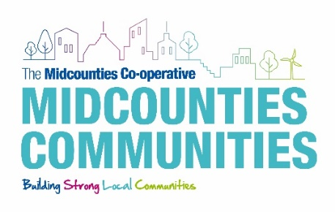     

**The Role of the Voluntary and Community Sector**

“*We know that a better future is about more than growing the economy. In a famous speech of more than 45 years ago, Robert Kennedy said that GDP ‘does not allow for the health of our children, the quality of their education, or the joy of their play. It measures neither our wisdom nor our learning; neither our compassion nor our devotion to our country; it measures everything, in short, except that which makes life worthwhile.’  
For many, the answer instead lies in civil society. It is charity and volunteering that allow them to find identity, meaning and purpose, a sense of autonomy, pride and utility. It is often how we find balance in our lives, pursue our passions, or fight for* *change. And for society at large, it is often how we build stronger communities, give people a say in what happens to them. It is how we provide services that people depend upon, develop new ways of doing things, and nurture the people who will lead our future.*  
**Sir Stuart Etherington, CEO of the National Council for Voluntary Organisations (NCVO) Jan 2018**

**HSWF helps families to thrive, not just survive.**



Registered Charity No 1120436 A Company Limited by Guarantee No 5419029