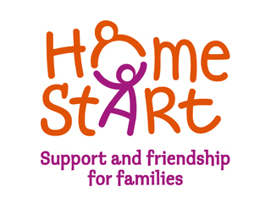

**Home-Start Wyre Forest**

Name, Job title  
Company name  
Date  
someone@example.com

Annual Report 2016/17

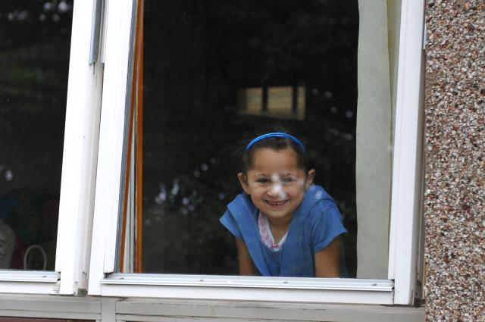

**Home-Start Wyre Forest**

Registered Charity No: 1120436 A Company Limited by Guarantee No 5419029

# Chairman`s Report

Welcome once again to the annual report for Home-Start Wyre Forest Wyre Forest. It has been another busy year with new challenges and opportunities for everyone involved.

The need for Home-Start help and support appears to be greater than ever. There is a need not only for our core service, which provides non-judgmental support and befriending to families with children under 5 through regular home visiting from our volunteers but there is also a need for the support which is now given to families with older children through home visiting and family groups. During the last year we supported 488 children in 244 families. Our wonderful volunteers continue to give excellent help and support to families with a whole variety of needs.

Two of our after school groups are funded by DY10 Big Local and are making a difference not only to the children who attend but they are also helping to reduce the isolation felt by many parents.

We are very pleased that it has been possible to open a daytime family group at the Salvation Army through Big Lottery funding and thanks to funding from the Midcounties Cooperative we have been able to introduce a new after school group in Stourport this year.

We are delighted to have been chosen by Midcounties Cooperative to be their Wyre Forest Charity of the year. Bag packing in Kidderminster and Stourport stores has already begun and a large number of their employees are joining our Home-Start Wyre Forest team for the Gung-Ho! sponsored event later in the year.

The Mayor of Stourport-on-Severn, Vi Higgs, has chosen Home-Start Wyre Forest together with Acorns to be her charity of the year.

We would like to give a big thank you to all our sponsors and funders, big and small, for their financial help and support. Also everyone who attends the fund raising events – fashion shows, Harmonikx evening, it is all very much appreciated.

We were very sorry that it was necessary to make two members of staff redundant, Heidi Preston and Nikki Beeston, we said a sad farewell to them in late 2017. We thank them for all their hard work at the scheme and wish them well for the future.

A big thank you to all the staff, lead very ably by Belinda, who work extremely hard too in providing appropriate help to the many families in their care and excellent support to all our volunteers.

I would like to thank all at Home-Start Wyre Forest Wyre Forest, staff, volunteers, Directors and all who support in any way so that together we can continue to provide an excellent service to our community by meeting the challenges and making the most of any new opportunities that arise.

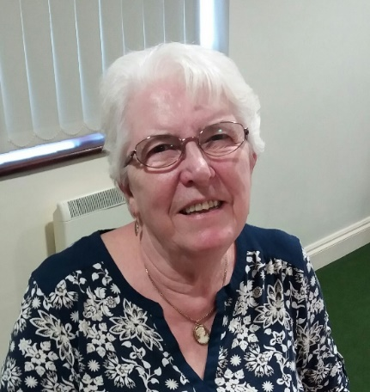

Megan Weaver

Chairman



# Life President`s Report

How quickly the AGMs come round!

As always it is a pleasure to think of everyone who contributes so much to the Scheme; the staff, the volunteers, the families and the trustees. Also of great importance are the businesses, companies, trusts and individuals who fund us: without this funding we couldn't survive.

The staff are adaptable and interested in all aspects of their work, many of which are challenging. I feel it is hard for them, as their hours are dependent on funding. Despite my disabilities I am able to offer non- managerial support to all the staff, and I enjoy performing this role.

Finally we owe a vast vote of thanks to Belinda for her never ending search for funding. On a personal note she is always thoughtful about finding venues which are accessible for me and my wheelchair.

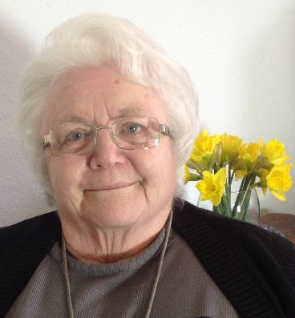

Barbara Hughes

Life President

**Treasurer`s Report**

Home-Start Wyre Forest began the new accounting period in October 2016 cautiously optimistic, with funding in place to December 2017.

Our friends and volunteers again raised money, and our bag-packing efforts at Marks and Spencer, for the first half of the year, have provided much needed unfettered income. Our scheme manager, Belinda Darby, continued to be very active in the pursuit of funding from organisations who may be able to support us going forward, with good success.

Home-Start Wyre Forest is, as ever, much indebted to a number of charitable trusts for their grants and donations. In addition, we are most grateful for the donations received from local organisations and from individuals. This support is essential, enabling us to continue providing the support to families which is the Scheme’s purpose.



In 2016, our income increased by £29,000 or 14%. We made a surplus of £35,000 (2016 £15,000). Big Lottery funding ended and these results include the final tranche of funding for the first quarter of 2017/18. The share of income from the public sector was <1% (2016, 8%). Again, none of our core service is publicly funded. Once again, the generosity of the people of Wyre Forest, and the tireless work of our fundraising committee, the team at Marks & Spencer and our army of bag-packers continue unabated. Fundraising income dipped due to the ending of Marks and Spencer support mid-year and donations continued to rise.

In the year to September 2017, our total income was £231,000 which is compared below with 2016 figures. Income was made up as follows:

|  |  |  |  |  |
| --- | --- | --- | --- | --- |
|  | **2017** | | **2016** | |
|  | **£** | **%** | **£** | **%** |
| Big Lottery Fund | 144,593 | 62.47% | 77,474 | 38.24% |
| DY10 Big Local | 25,017 | 10.81% | 13,807 | 6.82% |
| Children in Need | 24,688 | 10.67% | 16,134 | 7.96% |
| Wyre Forest District Council | 300 | 0.13% | 16,170 | 7.98% |
| The Henry Smith Charity |  | 0.00% | 27,900 | 13.77% |
| Garfield Weston |  | 0.00% | 10,000 | 4.94% |
| Comic Relief |  | 0.00% | 9,214 | 4.55% |
| MKR Charitable Trust |  | 0.00% | 7,000 | 3.46% |
| RD Weston |  | 0.00% | 2,000 | 0.99% |
| Bailey Thomas |  | 0.00% | 1,000 | 0.49% |
| Other Trusts | 24,189 | 10.45% | 3,285 | 1.62% |
| Fundraising | 5,555 | 2.40% | 11,227 | 5.54% |
| Donations | 6,448 | 2.79% | 6,197 | 3.06% |
| Interest Income and Gift Aid | 663 | 0.29% | 1,184 | 0.58% |
|  | **231,453** | **100%** | **202,592** | **100%** |
|  |  |  |  |  |

Grant making organisations receive large numbers of requests for assistance in these straightened economic times, so we thank those organisations who have been able to support us in 2017, and hope for continued support in 2018. Without their support, we would not survive. We are also grateful for the continuing work of our staff, friends and volunteers.

Our income in 2017 was budgeted at £164,000. The actual income of £231,000 was £67,000 over plan. This was as a result of meeting our charitable trust income budget and receiving 2017/18 income early. We budgeted expenditure of £184,000, but spent £196,000, partly due to the spending of a development grant received in –year from the lottery. This fully funded additional spend was to pursue alternate income and business development opportunities.

As a result of all this our cash balances increased as follows:

|  |  |  |
| --- | --- | --- |
|  |  | **£** |
| **opening cash 1 October 2016** | | **79,000** |
|  |  |  |
| income 2016/17 |  | 231,000 |
| expenditure 2016/17 |  | -196,000 |
|  |  |  |
| **closing cash 30 September 2017** | | **114,000** |

The surplus over the year translates directly into an increase of £35,000 in cash balances.

These results show an increase in cash balances, but much of this relates to 2017/18 funding received early. We have not been able to replace the Big Lottery funding and as a result have not had funding in place to support 2016/17 levels of activity.

Sadly, this has meant we have had to make cut-backs to protect services to those Wyre Forest families who need our help. We re-structured to ensure we continue with this work within the resources available to us. This has meant job losses and we were very sad to lose Heidi and Nikki at the turn of the year.

We continue to monitor income, expenditure and cash flow carefully on a monthly basis, so that we can respond appropriately and promptly to any changes in our financial circumstances. Our service is secure for the next year or so. We are fully focused on the financial security of our organisation. To this end, monitoring income, expenditure and cash flow very carefully, is vitally important.

We continue to pursue funding opportunities, and we start the year to 30 September 2018 chastened but still cautiously optimistic for the future of our service.

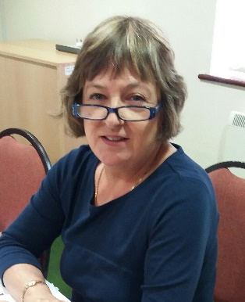

**Anne Taylor**

**Treasurer**

# What is Home-Start ?

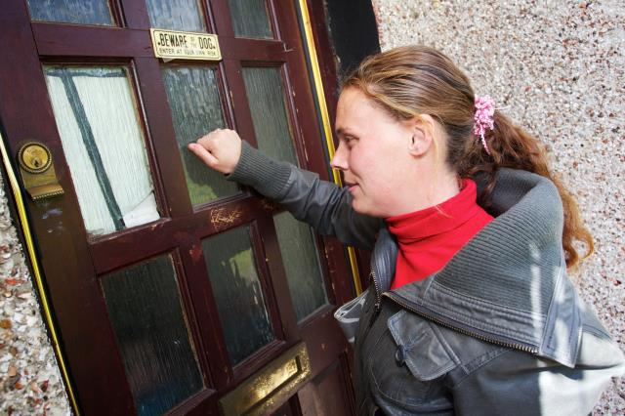

Home-Start Wyre Forest (HSWF) is a Family Support Organisation, offering practical and emotional support to parents with children in their own homes, helping to alleviate stress and prevent family crisis.

We can offer support to a parent who :

* has a child or is expecting a child
* lives in the Wyre Forest District
* is in need of support
* has consented to the referral .

Many families we support are experiencing difficulties with mental health, isolation, drugs or alcohol, housing, a multiple birth or may have experienced past traumas, such as domestic abuse.

Our core service is our weekly home-visiting volunteer visits, offering emotional and practical support and befriending. Families access support through regular home visits and a volunteer will visit a family for 2-3 hours each week to offer support with an agreed focus. This may include the volunteer providing conversation and a safe person to talk to, helping isolated families to play with their children and enjoy time together, despite the difficulties they are facing.

Most of all, the volunteer builds a trusting, friendly relationship with the family they support over a significant period of time. Our average support has increased from 6-9 to 9-12 months, but can be for as long as the family still evidence a need for support. We are certainly now seeing families with more complex needs that are less likely to need short term intervention.

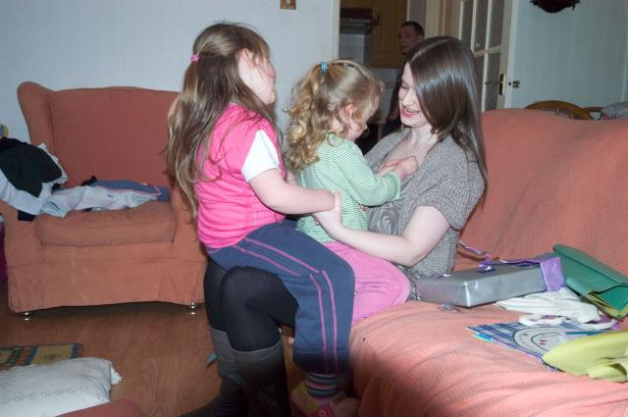

In 2017 we received 135 referrals and

supported 488 children in 244 families.

**Our Family Groups**

The main purpose of our Family Groups is to provide somewhere safe and supported for the most vulnerable families in our community to meet, form friendships and gain support. In addition to providing the standard weekly structured sessions the activities aim to enable families to enjoy their time together, feel part of the wider community and develop and feel proud of new skills.

Our Kidderminster After School Groups are funded by the DY10 Big Local Partnership (BLP). We run two sessions a week in the Horsefair Area of Kidderminster, open to all families in receipt of Home-Start support who have school aged children. The groups have been accessed in the past two years by some of the community`s most isolated families and it is noted the feedback we have had this year records 100% of parents attending feel they have made friendships through the group. In 2017 we asked the families who attend what does Family Group mean to them and they replied :

*Coming to group has given me friends, I get advice and my Granddaughter has blossomed. Her confidence is much higher. I love that I can mix or be by myself.*

*I get support when needed, people to talk to and friendship. I enjoy talking, coffee, laughs and seeing my children happy and playing.*

*Family Group is where I can talk to other mums and share my worries and get advice and support of how to sort my problems out. Both my daughter and I look forward to group. It helps me in many ways. I enjoy spending quality time with my daughter, doing arts and crafts and playing games which I wouldn`t be able to afford to do.*

*I love the friendship, the normal conversation, a good laugh and that the group is not overcrowded. Keep the same staff :o)*

These sessions are a way of promoting a sense of self worth, belonging and acceptance which many of these parents and children have never experienced.

Both HSWF and the Big Local Trust have a key role in connecting communities and providing the stepping stones to active participation in community life and so working in partnership to achieve the best outcomes for local families fits with both agency`s aims and objectives and is founded on a shared ethos of being family led . We can see these connections made through our Family Groups are the foundations for future social confidence and competencies which will be needed by the adults and child in these vulnerable families to manage future adversity and ensure a happy, safe and productive future, wherever their aspirations are focused.

During 2017, 23 parents and 30 children used these groups, providing an essential opportunity for social contact and interaction, emotional support and awareness of community services through attendance at Family Group.* One of our families called us the day after attending Family Group for the first time with her daughter and said ”

“*Thank you for a lovely evening, we loved it, K was a different child when we got home and came and gave me a hug. It isn’t much to most people but to us it was a lot, thank you.”*



**Our Daytime Family Group **

In 2017 we secured funding from The Big Lottery Awards For All fund to set up a daytime Family Group for parents/carers with children under five. The group has been attended by 23 parents/carers with 25 pre-school children in its first six months and, as with the After School groups, has been a safe place for isolated parents to gain support and form friendships.

Our Kidderminster Groups are hosted by HSWF Family Group Worker Sam and Co-ordinator Donna (seen here in full elf costumes for the group Christmas Party!)

In addition to this we have support from Volunteer Heather Hollis at each session and six further volunteers gave their time to support families to attend the groups during the year. This hand holding and availability of someone safe is key to our engagement of parents who may feel anxious about new or social situations, or have issues around trust.



**Stourport After School Group**

As we begin 2018 we have secured a Charity Partnership with Midcounties Cooperative in the Wyre Forest, who have enabled us to set up a weekly Group in Stourport for parents and their school aged children.

**Measuring Impact**

The support we deliver to families is recorded, monitored and evaluated through MESH, (Monitoring and Evaluation System Home-Start) which enables us to produce a Journey of Change (see below). This captures the “distance travelled” of each family and the impact of Home-Start support.

Our paid staff carry out needs assessments at the beginning, during and at the end of our support, to ensure our involvement is helping the family and to allow us to change the focus of support and to assess impact.

The majority of families we support will have numerous areas of difficulty and our flexible informal approach can ensure the family receives tailor made support in a way that meets their changing needs in the most meaningful way.

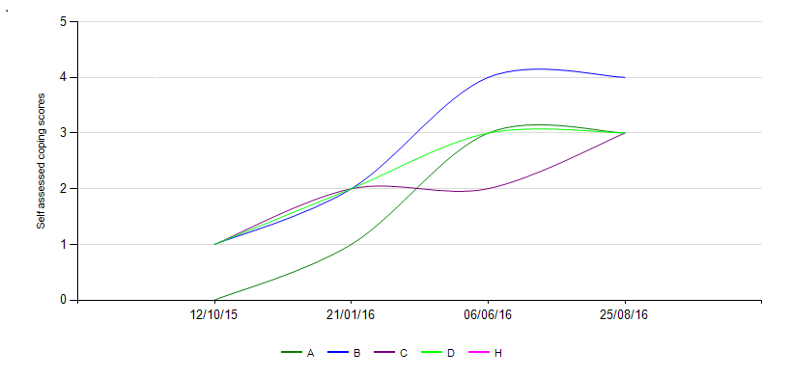

|  |  |  |  |  |
| --- | --- | --- | --- | --- |
| Date | A. Parenting Skills | B. Parent`s  Well being | C. Children's  Well Being | D. Family  Management |
| 12/10/15 | 0 | 1 | 1 | 1 |
| 21/01/16 | 1 | 2 | 2 | 2 |
| 06/06/16 | 3 | 4 | 2 | 3 |
| 25/08/16 | 3 | 4 | 3 | 3 |

This journey of change shows the impact of support on four areas of need.

“H” relates to the Hardiker Level of Need, which is also monitored.

Our unique befriending service over a significant period of time can produce life changing results for both parents and the children we support and particularly contributes to improved outcomes in the areas of parental and child health, emotional health and wellbeing (including past trauma), reduced isolation and managing child behaviour.

**Our Families say….**

“I can`t thank them all enough for the support they give me. I would be lost without them.” (Charlene, HSWF Family)

“They are fantastic and so good with families and giving out support.” (Kaleigh, family)

“Amazing help when I had both children and in a difficult relationship”.(Kim)

“Thank you for all the help you have given, it made a huge difference for our family. It allowed the children a normal childhood and the enjoyment of going to play.” (Amy)

**Our Referrers and partners say….**

“Home-Start provides vital support to families, both practically and emotionally and provide support in a friendly none judgmental way. Home-Start is great and have helped families make positive changes in their lives and maintain those changes”.(Melanie Taylor, Health Visitor)

“HSWF supports families extremely well! Through befriending, empowerment and critical friendship”. (Rosie Moss, Baxter High School)

“Brilliant local early intervention and flexible approach to supporting families. Non- judgmental, compassionate and practical help.” (Amanda Wright, Worcestershire Mental Health Link Network)

“It has been great to see how the group has been doing and also the passion and energy that your staff and volunteers have for doing it. To us, this kind of care and dedication to the local community is great to see, we can only give praise and encouragement for what you are doing and hope we can continue to work together.” ( Lt. Stephen Hollingsworth, Salvation Army Centre, Kidderminster).

**Our Volunteers say….**

“HSWF provides a wide variety of appropriate support to the families who need it. Support for the volunteers from the HSWF team is excellent and much appreciated. Good liaison between the team, families and volunteers ensures that the families get the best support available”. (Elaine, Volunteer for 5 years).

“ I have enjoyed all aspects of my involvement with Home-Start and feel the care given to volunteers is superb.” (Heather, Volunteer for 16 years).

“I am simply privileged to contribute to such a worthwhile charity, who tirelessly seek to overcome barriers to secure the best possible outcomes for children and families”.(Sue, Volunteer for 5 years).

“Volunteering for Home-Start has opened my eyes to the plight of some families in the community I live in. If my small input can help our amazing team keep one of these families safe and happy, then my life will be enriched as much as theirs. Long may Home-Start continue”. (Celia, Volunteer for 2 years).



**Our Volunteers**

We trained 13 new volunteers this year and a team of 108 community members volunteered their time during the year to deliver our service or govern the scheme.

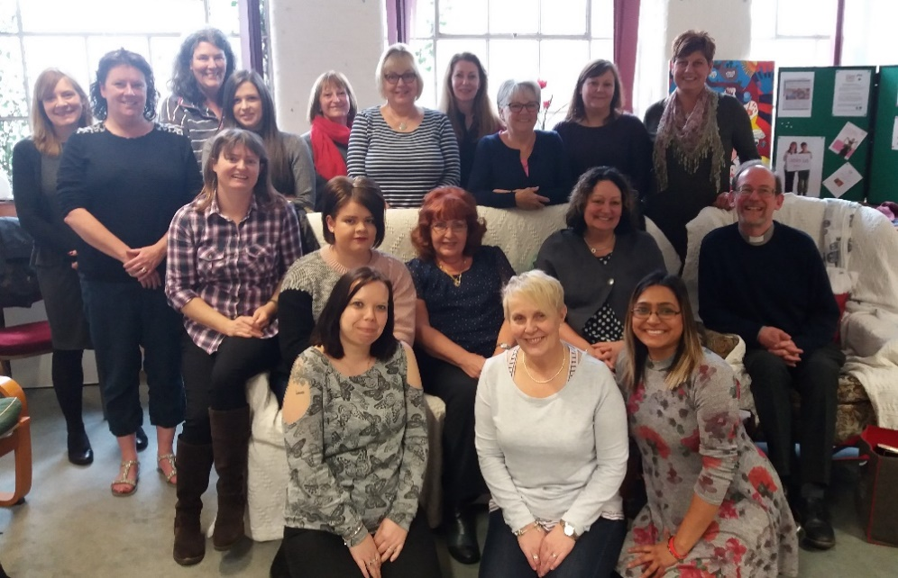

Prep Course March 17

All home visiting volunteers complete a 40 Hour Course of Preparation, covering many subjects including Safeguarding Children and Vulnerable Adults, Confidentiality, Mental Health, Communication Skills and Domestic Abuse. As part of our Safer Recruitment Practices we also carry out home visits, reference checks and obtain a Disclosure and Barring Service (DBS) Enhanced Disclosure for all prospective volunteers.

Volunteers are then offered **On-Going Training**, which this year included sessions on :

* Supporting Parents with Autism Spectrum Disorder
* Safeguarding Children and Young People Refresher
* Self Harm
* Cultural Awareness

All our training resources are uploaded to our website [www.homestartwyreforest.org.uk](http://www.homestartwyreforest.org.uk) to ensure those volunteers who cannot make the courses can gain basic awareness of the subject and as a place to refresh their knowledge of past training.

**Information and Inclusion**

Our newsletters are available to all volunteers bi-monthly, together with up to date news on our website. We encourage our volunteers to like our facebook and receive updates and news this way.

**Support and Supervision**

All volunteers receive regular support and supervision from a named

Co-ordinator while linked with a family and this is complemented by group support sessions, when volunteers can share experiences and discuss solutions around the challenges of volunteering in a confidential setting, facilitated by paid staff.

**Celebration and Acknowledgment**

Long service awards are presented each year at our AGM in the category of 5, 10 and 15 years service. In 2017 we awarded 15 Year Service Awards to our Safeguarding Advisor Jill Acton and our longest serving home visiting volunteer, Heather Hollis.

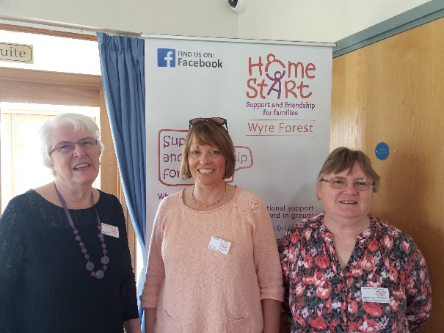

**National Volunteer Week**

In June 2017 we celebrated National Volunteer Week by hosting a Coffee Morning by the lake at Bodenham Arboretum, with a “Musical Thank you” performed by vocal group Harmonikx.

National Volunteer Week is an Annual opportunity to officially thank our amazing team of volunteers for the time, energy and commitment they give to the scheme each week, whether by home visiting, help at our Family Groups or by governing the scheme as charity trustees and advisors.

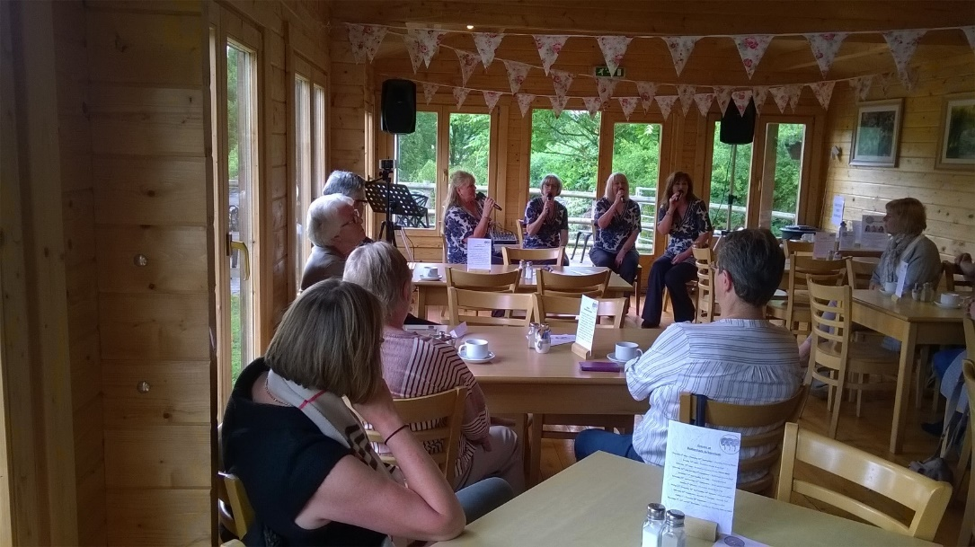

Harmonikx performing a Musical Thank you for our team



**Scheme Development** 

For the past three years we have worked in partnership with the team from the Family Psychologist to offer free therapy sessions to any parent we are supporting who has disclosed childhood abuse. We then worked to develop further partnership business plans, having recognised the power of “housing” clinical services. This enables staff and volunteers to provide practical and emotional support for the most vulnerable members of our community to attend therapy sessions and engage with a clinician in a way which feels comfortable to them. Together with Dr Rachel Johnson and James Johnson (below) from The Family Psychologist we developed a business model for a “Safe & Strong” service, offering psychology and social support to adults and children.

 

In 2017 we secured a £15,000 Lottery Building Capabilities Grant to develop this idea further, with the support of Consultant Chris Allen (below) from Compass Community Partnerships Ltd.

 

Following work with our Board and local partners, a steering group was formed with support from the Chair of our Big Local Trust, Brenda Lines. We agreed to form a Community Benefit Society, **Future Families**, to operate as a social enterprise offering social and psychological support to the community.

In 2018 Lloyds Bank Foundation agreed funding to register the society and support development costs for 2018-20 and in February 2018 Future Families gained registration with The Financial Conduct Authority.

Our five founding directors were identified and Jo Allen (below left) and Margaret Jones (below right) joined Rachel, Jamie and HSWF Manager Belinda Darby to set up the new company.

 

The directors are now seeking capital and revenue funding to set up and run the Future Families Hub – to offer mental health and social support – to adults and children in need of services who do not meet the criteria for NHS services, or are unable to engage due to issues around trust, stigma and accessibility.

The Future Families Hub will need to operate as a Social Enterprise in order to become sustainable and the model below shows our plans for housing income generating services (Creche, Community Café, Meeting room hire) with grant funded services (Safe & Strong and HSWF).



**Therapy Room**

**)**

**Safe and Strong**

**(**

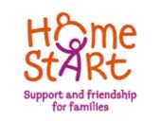

**Home-Start Wyre Forest Wyre Forest**

**Offices**



**Community Café**



**Creche Facility**



**Meeting Room**

**Multi**

**(**

**-**

**purpose available**

**for hire)**



**Donation**

**Room**



**Community**

**Navigators**



**Reception**

**and**

**Information**

**Point**

**What will Future Families do?**



 We will develop sustainable services to members of the public, with a priority towards the most vulnerable.

 We will provide access to meeting places, child care facilities, mental and emotional health support, financial literacy, low cost goods, and other opportunities in line with its objects.

 We will enable our community to gain through support and therapy increased confidence and mental health resulting in **greater personal resilience and an improved quality of life.**

Future Families can now offer nonrefundable membership shares in the company at £1 each to promote community ownership and involvement and we would welcome hearing from any community members who would like to join our Stakeholder Group or Management Committee.

Please visit www. ourfuturefamilies.co.uk or www.facebook.com/ourfuturefamilies for more information, or ask us for a copy of our Business Plan.



**Charity Partnerships**

**Charity Partner of Kidderminster Marks & Spencer**



We were delighted to have continued our partnership with Kidderminster Marks & Spencer into a second year as their Local Charity. We continued bag packing in the store each month and the store continued to arrange events with their employees and customers to raise a grand total of £9,405 throughout the year. When added to our Year One total, this partnership raised an amazing £16,066 in unrestricted funds for us during our two year Charity partnership with Kidderminster M&S.

**Charity Partner of Kuraray Monosol**

In 2017 we were also a Named Charity with Hartlebury based company Monosol, who provided our families with School bags for the start of the School year and Christmas stockings filled with goodies in December. Photo shows Julie Jarvis (l) and Sheila Morris (r) from Monosol with HSWF Senior Co-ordinator Donna Scriven.

 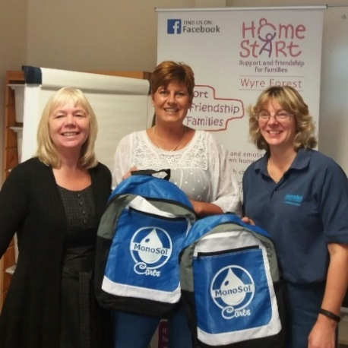

**Charity Partner of Stourport TSB**

We were named as Charity of The Year by Stourport Bank TSB and the staff team and customers raised £396.81 for us during the year through customer donations and seasonal raffles.



**Small change can make a big difference**

During 2017 we were supported by Gemma Taylor Robinson, Founder of GTR Business Development, who regularly works with clients to develop their business, to engage local companies to promote partnership working. Gemma gave her time voluntarily to the scheme and as part of this work we launched the “**Small change can make a big difference** “ campaign, which had enabled us to place collection tins in 15 local businesses!

 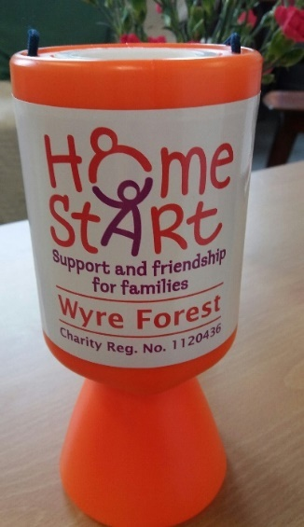

**Fundraising Events**

During the course of the year volunteers and supporters arranged various events to raise much needed unrestricted income for the scheme and to raise our community profile. This year we have received funds from:

* M & Co Fashion Show
* Harmonikx at the Gainsborough Hotel
* Gung-Ho! 5KM Seriously Fun Challenge



**The 2017 Gung-Ho! Team, running for HSWF.**



A team of 12 runners took part in the 5km Gung-Ho! Inflatable Obstacle Course Challenge at Cofton Park, raising £645 for the scheme. 

**What Family Means to Me**

 

Heronswood Primary School

This was a partnership project between charity Home-Start Wyre Forest and Heronswood Primary School completed during 2017. The purpose was to produce lasting artwork for the scheme meeting room and an online portfolio to capture what “Family” means to local school children. A Nurture Group of 10 boys and girls aged between 7 and 9 years old. They produced some amazing art which is on permanent display in our meeting room and can be viewed in our online album on our facebook page

[www.facebook.com/homestartwyreforest/albums/whatfamilymeanstome](http://www.facebook.com/homestartwyreforest/albums/whatfamilymeanstome)

The children and their parents joined Lesley Fox from WFDC (below left) and their teachers (below right) at the scheme for a celebration Afternoon Tea party to unveil the art and congratulate the children on their work.

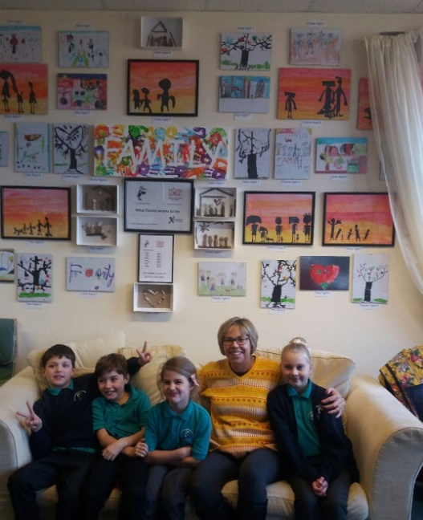 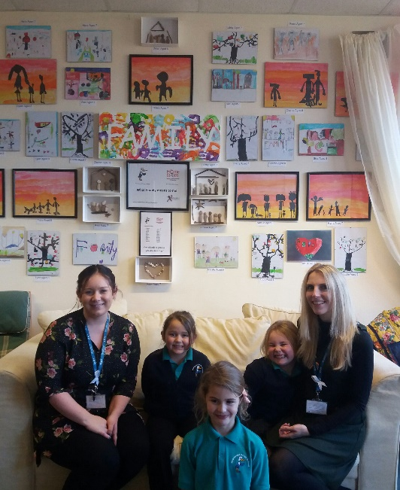

 

Harry Aged 7 years Tyler Aged 8 years

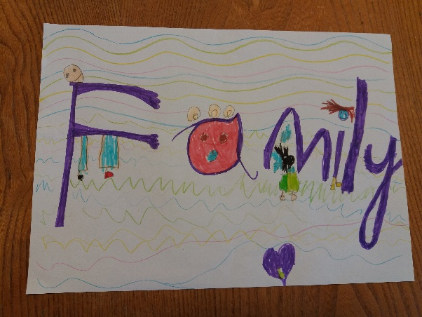 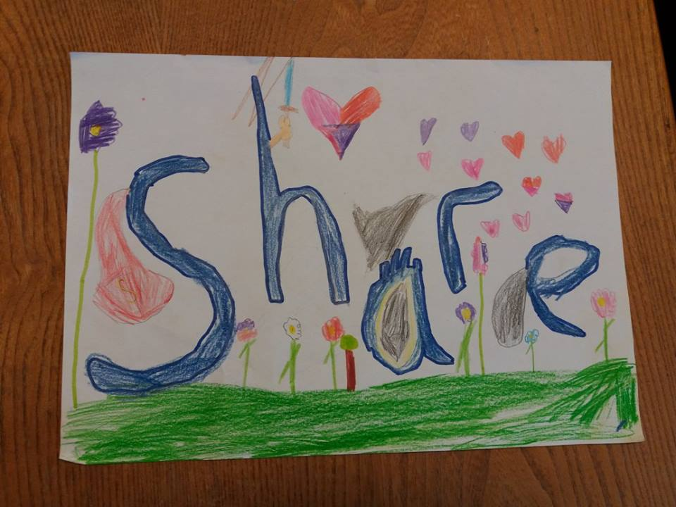

Libby Aged 7 years Chase Aged 7 years

 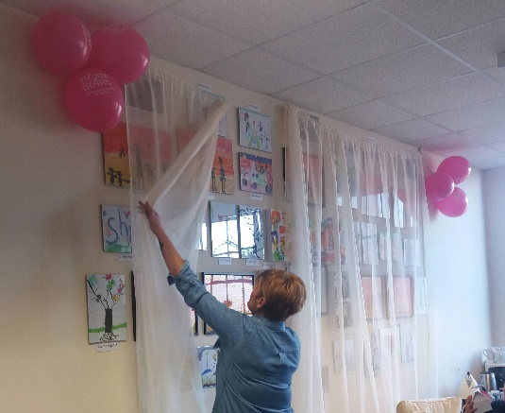

The project space -HSWF meeting room The grand unveiling

    

**A day at the seaside**



Bags of Help Funding from Tesco enabled us to take our families on a day trip to Weston in the summer, where families were able to relax and create shared memories away from the stresses of home. Unfortunately, our return journey coincided with an unprecedented delay on the motorway caused by an accident, resulting in our families arriving back in Kidderminster in the early hours of the morning.

Despite this, our staff, volunteers and families showed true kindness and tolerance, one family even sending a special card to the coach driver, to thank him for getting us all home safely.





**Christmas Toy Appeal** 

We were delighted to be partners once again in the Kidderminster Shuttle Christmas Toy Appeal, where members of the public bought gifts for the children of families who were receiving support from us and passed them on through the scheme anonymously. Over 750 gifts were donated in December 2016 and passed onto families, demonstrating true community spirit and making the festive season a little happier.



**Snowflake Appeal**

Our Annual Appeal runs from November to January and encourages supporters to arrange Snowflake themed events to raise funds for HSWF. This year our volunteers had themed dinner parties, raising over £200.

** **

**The HSWF Team**

|  |  |  |
| --- | --- | --- |
| **The Board** |  |  |
| Megan Weaver | Chairman | Current |
| Barbara Hughes | Life President/Vice Chairman | Current |
| Anne Taylor | Treasurer | Current |
| Roger Bourne | Director | Current |
| Linda Small | Director | Current |
| Rev. Phil Hoar | Director | Current |
| Tracy Wilkes | Director | Current |
| Jill Acton | Safeguarding Advisor | Current |
| **The Staff** |  |  |
| Belinda Darby | Manager | Current |
| Donna Scriven | Co-ordinator | Current |
| Joanne Shinton | Co-ordinator | Current |
| Sam Littleton | Family Group Worker | Current |
| Lynda Williams | Scheme Secretary | Current |
| Heidi Preston | Co-ordinator | To Dec 17 |
| Nikki Beeston | Scheme Support Worker | To Dec 17 |

**Thank you to our wonderful volunteers:**

Amanda, Amie, Ann, Brenda, Celia, Charlotte, Christine, Dawn L, Elaine P, Ellie, Esther, Everleen, Gary, Harj, Heather, Helen B, Helen H, Jackie, Jane, Jayne, Jenny, Jodie, Joy L, Joy P, Julia , Julie B, Julie P, Julie S, Julie S, Katie, Kayleigh, Karen G, Karen W, Kim, Kizzy, Lakami, Lara, Laura, Lesley B, Lesley D, Liz I, Liz H, Louise G, Louise S, Louise T, Lucie M, Lucie P, Lynne, Margaret, Marjorie M, Marjorie W, Marissa, Marnie, Maz, Megan, Myra, Nancy,

Nicky A, Nicky P, Norma, Pauline, Rosalind, Rosie, Sally, Sam A, Sam G,

Sam M, Sam W, Sandra, Sara, Sarah H, Sarah M, Sophie, Stacey, Sue H,

Sue P, Sue R, Sue S, Tracey F, Tracey T, Tracy C, Trina, Zarina.

**Contact us**

**Home-Start Wyre Forest**

MCF Complex, 60 New Road,

Kidderminster, Worcestershire.

DY10 1AQ

Telephone : **01562 825896**

Email :homestartwyrefor@btconnect.com

[www.homestartwyreforest.org.uk](http://www.homestartwyreforest.org.uk)

[www.facebook/homestartwyreforest](http://www.facebook/homestartwyreforest) 

 



Registered Charity No: 1120436 A Company Limited by Guarantee No. 5419029

**The Role of the Voluntary and Community Sector**

“I see it as an integral part of our role that we place building connections between people and building community at the heart of our work.  
Some of these things we’ve always done are now more important than ever. Your organisations connect people to causes, connect people to one another, connect them to something larger than themselves and give them a way to make a difference to the world around them.

Over the coming year we will see lots of debate on the outlook for our sector. The Future of Civil Society Inquiry will be working towards its conclusions to be launched in 2019. Whatever the sector looks like in ten or twenty years, there is no doubt in my mind that a core, defining part of our work will be these connections we build.”

**Sir Stuart Etherington, CEO of the National Council for Voluntary Organisations (NCVO) Jan 2018**

