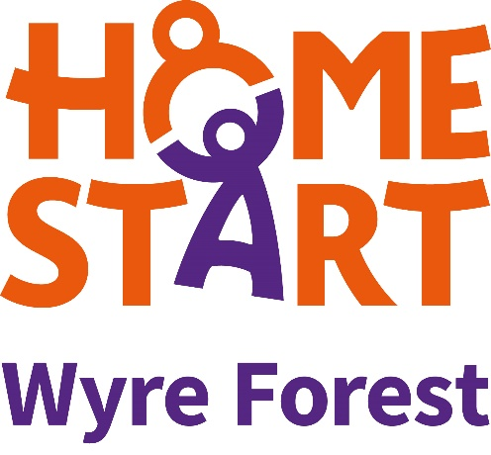

## 

## **Sponsor Form**

(Add your challenge details here)

|  |  |  |  |  |
| --- | --- | --- | --- | --- |
| Name | Postcode | Amount | **Tick if Paid** | **Gift Aid** |
|  |  |  |  |  |
|  |  |  |  |  |
|  |  |  |  |  |
|  |  |  |  |  |
|  |  |  |  |  |
|  |  |  |  |  |
|  |  |  |  |  |
|  |  |  |  |  |
|  |  |  |  |  |
|  |  |  |  |  |
|  |  |  |  |  |
|  |  |  |  |  |
|  |  |  |  |  |
|  |  |  |  |  |
|  |  |  |  |  |
|  |  |  |  |  |
|  |  |  |  |  |
|  |  |  |  |  |
|  |  |  |  |  |
|  |  |  |  |  |
|  |  |  |  |  |
|  |  |  |  |  |
|  |  |  |  |  |
|  |  |  |  |  |

**Thank you so much for supporting us**

A company limited by guarantee 5419029 Registered Charity Number: 1120436

Or use PayPal Giving on our website

[www.homestartwyreforest.org.uk](http://www.homestartwyreforest.org.uk)



**SEND DONATIONS TO**

MCF Complex, 60 New Road, Kidderminster DY10 1AQ

Tel: 01562 825896

Email: info@homestartwyreforest.org.uk